Illinois Association of Vocational Agriculture Teachers
Agricultural Issues CDE

Contest Superintendent – Ann Piotrowski, DuQuoin
IAVAT CDE Committee Member – TBA
Host – Dr. Andrew Baker, Western Illinois University Ag Education Professor

Purpose of the Event
The integration of agricultural issue analysis in local school academic subject matter areas will help students develop an understanding of local, state, national and international issues facing agriculture today and in the future. Students gain an understanding of the principles and fundamentals of agricultural issue analysis as they select, research, plan and presentation of an agricultural issue. The event promotes career choices by providing an opportunity for individuals to become acquainted with professionals in the industry as they acquire knowledge and skills in community leadership.

General Information
  - Team: A team shall consist of a minimum of three and a maximum of seven students who are actively participating, orally presenting and available to answer the judges’ questions. Each student must take an active role in the presentation in order for the team to qualify for awards. This includes active participation in the presentation and making themselves available for questions from the judges in all rounds of competition.

Registration
    - Schools interested in participating in the State Ag Issues CDE must file an “Intent to Participate” form with their IAVAT District Director on or before April 1st
    - When more than two schools from the same district file an “Intent to Participate” form, the IAVAT District Director will conduct a District Agricultural Issues CDE on or before May 15th.
    - The teams with the top two scores in a district event shall advance to the State Agricultural Issues CDE.
    - Two schools from each IAVAT District may compete in the State Agricultural Issues CDE. A third place team from district competition will not compete in the state event, unless the third place team from each district can be accepted and the total number registered for state competition does not exceed ten teams.
    - Teams participating in the state event by using a video link from a satellite location, will be eligible for awards only when the IAVAT District Director or their designees is present at the satellite location to monitor the presentation.
    - Entry fees are not refundable.

Miscellaneous
    - Presentations may include official FFA dress, costumes, props, skits and other creative paraphernalia.
    - The purpose of the agricultural issues forum is to present a current issue to a public audience; therefore, professional ethics and standards are to be considered. Ignoring truthful information, falsifying needed information, using unreliable sources and plagiarism are violation examples which could result in disqualification.
    - No one will be allowed to observe any presentation.

Scoring & Awards
    - A minimum of three competent and impartial persons will be selected to judge the CDE. They will be instructed not to take sides on the issue(s). Professors and industry representatives are recommended as judges.
    - During the presentation, the judges will be seated in different sections of the room in which the event is held and they will score each presentation, using the score sheet provided.
    - Each judge shall formulate and ask questions that pertain directly to the team’s issue.
    - Each judge will score the team presentation and the questions asked by all judges.
    - The full seven minutes for questions should be used.When all participants have finished speaking, each judge will total their score on each participant.
      - Participants shall be ranked in numerical order by each judge without consultation with any other judge.
      - If any judge's scoring results in a tie between two or more presentations, the judge shall be asked to re-score so as to avoid the tie.
      - After a judge has broken all ties in total score they will rank all presentations in numerical order without consulting any other judge. The rankings of the three judges shall then be added and the winner will be the team whose total of rankings is the lowest. Other placings shall be determined in the same manner (Low point score method of selection).
      - If a tie occurs when adding the rankings of the three judges, the team who has the highest grand total score shall be ranked higher.
  - Additional Information: Refer to National FFA Career Development Events manual.

Career Development Event Format
  - The issue will come from one of the following eight agricultural issue topic areas as listed in the Focusing on Agricultural Issues instructional materials:
    - Environmental Issues
    - Agricultural Technology Issues
    - Animal Issues
    - Agricultural Career Issues
    - Economy and Trade Issues
    - Agricultural Policy Issues
    - Food Safety Issues
    - Biotechnology
  - Research on the topic must be current and students must be involved in all the research of the topic and development of the portfolio.
  - The same agricultural issue presentation and/or portfolio will not be used in subsequent years by the same chapter and/or advisor.
  - The portfolio should include items described in i, ii and iii below.
  - Portfolios are due (postmarked) to the host of the State Event on or before June 1st.

Career Development Events Divisions
  - Team Presentation
    - Introduction, Pro, Con and Summary of Pro and Con (20 points each, 80 points total) There will be a 5-point deduction from the scorecard of any team that draws a conclusion supporting a pro or con viewpoint during the formal presentation.
    - Overall presentation (participation of each member of the team, quality and power of the presentations, creativity, stage presence) ( 20 points)
    - Questions (25 points)

Portfolio
    - The portfolio is limited to ten pages single-sided or five pages double-sided maximum, not including cover page.
    - The portfolio shall consist of three parts, worth a total of 25 points.
- The cover page will include the title of the issue, the date of the state qualifying event, name, address and phone number of the chapter.
- Summary of the Issue (5 points) - A maximum of two pages of the portfolio will include a summary of the issue, answering the questions that are most relevant to your topic:
- List course(s) in which instruction occurred including the number of students involved in the instruction of the issue. (See Objective 6.)
- Why is this issue important now?
- What is the nature of the issue?
- Who is involved in the issue?
- How can the issue be defined?
- What is the historical background of the issue? What caused the issue?
- What are the risks?
- What are the benefits?
- Is there strong disagreement on the issue?

- Bibliography (5 points) - A bibliography of all resources and references cited which may include personal interviews and any other supporting material.
- Documentation of Local Forums (15 points) - Each team will conduct presentations on the issue developed and presented at the local level. A chapter must have a minimum of five high quality public forums prior to their state qualifying event in order to receive the maximum of 15 points. The documentation of the presentations at these local forums is required and should include:
- When were the forums presented
- Where were the forums presented
- To whom were the forum(s) presented
- How many community members were in attendance at each of the forum(s)
Documentation that local forum(s) occurred prior to the District qualifying event such as:
- Letters from organizations
- News articles
- Photos showing attendance at forums

Notes on Forums:
Forum presentations given after having won the district competition are encouraged, but will not count toward the portfolio score.
Multiple organizations attending the same forum will count as one forum.
If more than one forum is held on the same day, the starting time of each forum must be independently documented.
Portfolio judges may take into consideration the quality and quantity of presentations made to audiences outside of the school.
No points will be awarded for school presentations to teachers and students.
In addition, no points shall be awarded for forums presented as any part of a local or state FFA competition.
    - A maximum of ten (10) points will be deducted for exceeding the maximum amount of pages and /or for not including the cover page containing required information.
    - Five copies of the portfolio must be sent to the event host on or before June 1st.

Time Limits
  - Five minutes will be allowed for set up.
  - The presentation will be a maximum of 15 minutes in length.
    - The presenters will receive a signal at 10 minutes and 14 minutes.
    - At 15 minutes the timekeeper will announce that time is up, and the presentation will end.
  - A maximum of seven (7) minutes for questions and answers will be allotted.
    - Questions and answers will terminate at the end of seven (7) minutes.
  - Three (3) minutes will be allowed for take down.

Portfolio Score Sheet

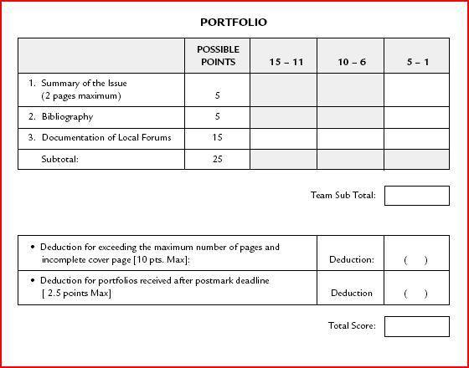

Presentation Score Sheet

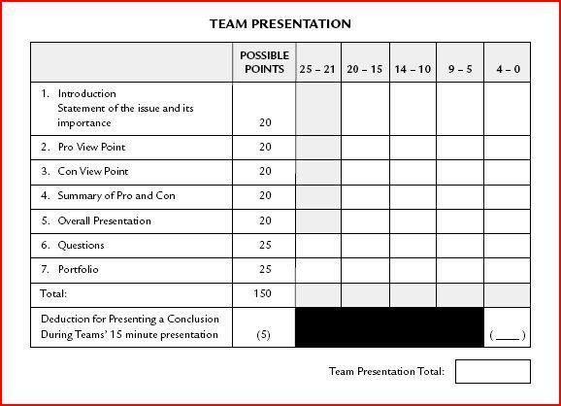

- References (This list contains references that may prove helpful during event preparation, is not intended to be inclusive. Other sources may be utilized and teachers are encouraged to make use of the very best instructional materials available.)

Updated Focusing on Agricultural Issues Instructional Materials
Located at: http://web.ics.purdue.edu/~peters/ and is available for purchase through The Core Catalog, National FFA Organization.
Agricultural Issues: Ground Water Safety Video, available for purchase through The Core Catalog, National FFA Organization
“Helpful hints to give your students the best opportunity to do well in the Agricultural Issues Forum Career Development Event at the State and National FFA Conventions” Located at http://web.ics.purdue.edu/~peters/ and on the National FFA Website at link: http://www.ffa.org/programs/cde/documents/cde_agissues_resources.pdf

Agricultural Issues CDE
Intent to Participate Form
Due to your District IAVAT Director by April 1st
Chapter _ .

Preferred Time of Presentation: _ .

Identify which of the eight agricultural issue topic areas your presentation will focus on:

Environmental Issues
Agricultural Technology Issues
Animal Issues
Agricultural Career Issues

Economy and Trade Issues
Agricultural Policy Issues
Food Safety Issues
Biotechnology

Tentative list of team member:
(Teams may include a minimum of three and a maximum of seven participants)

1. 2.
3. 4.
5. 6.
7.
- Schools wanting to participate in the State Ag Issues CDE are required to send an Intent to Participate form to their District IAVAT Director by April 1st.
- If more than two schools in a district submit an intent, the District IAVAT Director will hold a District Ag Issues CDE no later than May 15th.
- All forums documented in the portfolio must be completed by May 15th.
- Results of the District Ag Issues CDE will be due to the Illinois FFA Center no later than May 15th.
- Qualifying teams for the state competition must submit portfolios no later than June 1st.
- The top two teams from district competition shall advance to the state event and should all presentation times not be filled, the host will allow the participation of all third place teams in district competitions.

