Illinois Association of Vocational Agriculture Teachers

Food Science & Technology CDE

Contest Superintendent – John Heiser, Putnam County
IAVAT CDE Committee Member – Liz Harris, Normal Community
IAVAT CDE Committee Member – Colby Gregg, Naperville Central
Host – Luke Allen, FCAE District 2 Program Advisor
Mary Cwikla, Weitendorf Ag Center Facility Manager

Purpose of the Event
To stimulate learning activities in food science and technology related to the food industry and to assist students in developing a good working knowledge of sound principles used in a team decision-making process.

Objectives
- To encourage FFA members to gain an awareness of career and professional opportunities in the field of food science and technology, marketing and management occupations.
- To give FFA members the opportunity to experience group participation and leadership responsibilities in a competitive food science and technology program.
- To help FFA members develop technical competence and personal initiative in a food science and technology occupation.
- To provide opportunities for FFA members to participate in activities where they gain an appreciation for cooperative effort in the food industry.

A. General Information
1. Team: A team shall consist of four (4) members, with all four scores counting towards the team score.
2. Awards: All scores will be added to calculate the team score. Individual awards will be based upon the total of the objective test score, a practicum in food safety and quality and a practicum in sensory evaluation.
3. Scorecards: The score card used in the event will be posted on iavat.org
4. Miscellaneous: Each participant must have a clean, free of notes clipboard, two sharpened No. 2 pencils and an electronic calculator. Calculators used in this event should be battery operated and non-programmable. No other calculators are allowed to be used during the event. Teams and/or individuals will not be permitted to use electronic media during the event.
No outside food or drink will be allowed at this competition. Water will be available for the participants.
Every effort will be made by the host to refrain from any use of nuts or nut products. IAVAT is not able to guarantee, however, that nuts or nut products will be void from the event site.
5. Registration: This event shall be open to any school desiring to participate. Pre-registration for this career development event is expected by a deadline to be announced through the Ag Ed Listserve. Entry fees are not refundable.
6. Tiebreakers: Should a tie occur in the overall team placing, the tie will be broken by the highest team product development project score. If this score does not break the tie, then the highest number of total points earned from the objective test (adding all four team member scores) will break the tie. To identify the high individual for this event in case of a tie, the highest examination score will be used as the first tiebreaker, followed by the highest Food Safety and Quality practicum score, as the second tiebreaker.
7. Additional Information: Refer to National FFA Career Development Events manual. Please be aware that allergens may be present at the contest site.

B. Career Development Event Format
The career development event shall consist of three parts: Objective Test, Individual Practicums and the Team Marketing Scenario.

C. Career Development Events Divisions
1. Objective Test: (100 points)
The objective test is designed to determine each team member’s understanding of the basic principles of food science and technology. It will encompass the knowledge required of the team event and the two practicums, i.e., food safety and quality and sensory evaluation, as well as material in the list of references.
a. Team members will work individually.
b. The test will consist of fifty (50) multiple-choice questions.
c. The test questions will be based on the attached list of required references.
d. Fifty (50) minutes will be allotted to complete the Objective Test, with each question worth two (2) points for a total of 100 points.

2. Practicums:
Each team member will compete in all three practicums. The event host will furnish all materials used in the practicums.

a. Food Safety and Quality Practicum
Customer Inquiry Scenario (25 points)
Using a multiple-choice response card, each participant will be respond to five (5) scenarios based in which they will determine if the situation involves a food quality or food safety problem and respond accordingly.
Regardless of the problem each participant will record their answer.
Identification of Problem
        - Cause of Quality Defect. . . . . . . . . . . 10 points (5 at 2 points each)
        - Identify the Nature of the Problem. . . . .15 points (5 at 3 points each)
Fifteen (15) minutes will be allowed for this part of the practicum.
b. Sensory Evaluation
Each participant will be given one minute at each station before being told to move to a new station. When each person returns to his or her original station this practicum is completed
Part I - Triangle Tests (20 points)
Four different triangle tests will be conducted. Participants are expected to identify the different samples through flavor, aroma, visual cues and/or textural differences. Answers will be given on the sheet provided. No list will be provided for this segment of the practicum. Each test is worth 5 points.
Part II – Aromas (60 points)
Each participant will be asked to identify 6 different aromas from vials provided at each station and record the answer on the sheet provided. Each station is worth 10 points. A list of potential aromas will be provided to each person. Possible aromas include:

10. Apple | 21. Ginger | 32. Peach
11. Banana | 22. Grape | 33. Peppermint
12. Basil | 23. Lemon | 34. Raspberry
13. Butter | 24. Licorice (anise) | 35. Sage
14. Cherry | 25. Lime | 36. Smoke (liquid)
15. Chocolate | 26. Maple | 37. Strawberry
16. Cinnamon | 27. Molasses | 38. Vanilla
17. Clove | 28. Nutmeg | 39. Watermelon
18. Coconut | 29. Onion | 40. Wintergreen
19. Coffee | 30. Orange
20. Garlic | 31. Oregano

c. Math Practicum (25 points)
The participant will complete 5 multiple choice questions at 5 points each.Questions may include nutrition calculations, ingredient quantity, cost benefit analysis, estimation of cost/margin of goods sold, conversions, processing conditions, etc.

Example Question:
The perfect glass of sweet tea is 20 percent sugar. Jim is making a one-gallon container of sweet tea. How many cups of sugar should he add?

- 2.4 cups
- 3.2 cups (correct answer)
- 3.4 cups
- 4 cups

Conversion Chart for Basic Liquid Measurements (US) to be used at the State CDE
1/2 fl oz = 1 tbsp = 3 tsp
1/8 cup 1 fl oz 2 tbsp 6 tsp
1/4 cup 2 fl oz 4 tbsp 12 tsp
1/2 cup 4 fl oz 8 tbsp 24 tsp
1/4 qt 1/2 pt 1 cup 8 fl oz
1/2 qt 1 pt 2 cups 16 fl oz
1/4 gal 1 qt 2 pt 4 cups 32 fl oz
1/2 gal 2 qt 4 pt 8 cups 64 fl oz
1 gal 4 qt 8 pt 16 cups 128 fl oz

3. Team Event: (300 points)
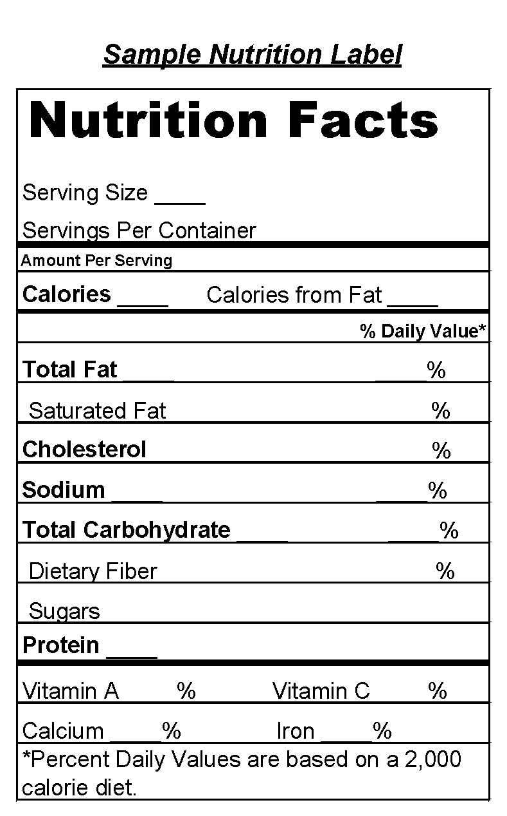
Each team will receive a marketing scenario describing a need for a new or redesigned
product that would appeal to a potential market segment. This scenario will contain a description of the existing marketing situation, competition, economic considerations and potential target market segment to be served by the new product. It is the task of the team to design a new food product or reformulate an existing product.

The team will be responsible for understanding and using the following concepts:
        - Formulation of product to meet specified market requirements.
        - New package design to reflect the developed product.
        - Nutritional label development and adjustments.
        - Equipment used to produce and package the product.
        - Provide quality control and safety programs, i.e., good manufacturing practices (GMP) and hazard analysis critical control points (HACCP).

Each team will be provided with packaging materials, ingredients and information necessary on each ingredient in order to develop a final product label. The team will respond to the marketing scenario and reformulate or develop a new product, calculate a nutritional label, develop the ingredient statement and educational panel and develop the front or principal display panel to reflect the new product and its market.
Possible products to include, but are not limited to:
Cereal
Breakfast Bars Candy
Snack Mixes
Dairy Products
Desserts
Beverages
Pizza
Processed Fruit Snacks
Sandwich
Convenience Meals
Stir-Fried Vegetables

Total time involved for each team will be sixty (60) minutes. Total number of points possible for this activity will be 300 points.

D. Required References

Food Science and Safety, 2nd Edition, 2004, George J. Seperich, Pearson Publishers

Food Science: The Biochemistry of Food and Nutrition, 2002, Mehas & Rogers.
This curriculum contains a student text, student lab manual, teacher’s annotated lab manual, and teacher’s resource binder. All materials are available through the Glencoe Secondary Catalog: Family & Consumer Sciences.

Additional References

Principles of Food Science, 4th Edition, 2015, Goodheart Wilcox ISBN: 978-1-61960-436-0

Principles of Food Sanitation, 5th Edition, 2006, Norman G. Marriott and Robert B. Gravani, Springer Science + Business Media, Inc.

USDA Food Safety and Inspection Service website, http://www.fsis.usda.gov

Penn State Kitchen Chemistry: Experiments, resources and materials for educators and students, http://foodscience.psu.edu/public/kitchen-chemistry

Food Safety Education, http://www.fsis.usda.gov/food_safety_education/for_kids_&_teens/index.asp

Partnership for Food Safety Education, http://www.fightbac.org

FoodSafety.gov, http://www.foodsafety.gov

