Illinois Association of Vocational Agricultural Teachers
Poultry Career Development Event

Contest Superintendent – Steve Buyck, Liberty
IAVAT CDE Committee Member – Mike White, Paxton-Buckley-Loda
IAVAT CDE Committee Member – Darin Blunier, Midland
Host – Nick Wherley, ITCS Media/Communications Specialist

GENERAL INFORMATION

Team
Five team members from each school are permitted to judge. The three individuals earning the highest total scores constitute the team score (a school may compete with three members).
A school may enter less than a full team, but then the member(s) will compete only as individuals.
No substitution is permitted in any division after judging has started and extra students
are not permitted to judge.
Handling of live birds (in Classes 1 & 2) is not permitted. Handling of eggs is permitted only in Class 7.
Each participant should have a pencil. In addition to the placing cards provided by the event superintendent, a clipboard (optional) may be used, and also a piece of paper (4 x 6 inches or less) may be used to record placings for the participant’s use. There should be no written material on paper or clipboard at the start of the event.
Students are not required to give reasons on any rings.
Every possible effort is made in computing the results to prevent errors. If, however, after the precautionary measures have been taken and the results announced, errors do show up, the results will stand as announced and will not be corrected at a later date.

Additional Information
Refer to the “General Rules” section for the current year for information concerning Entry Fees, Registration and Location of the event. Scantron Card #478-7 will be used for this event.

5. Miscellaneous
Immediately after the event, the official placings for the rings are given.
Coaches and participants are not permitted in the rooms where the rings are located prior to the event. Non-participants should observe the rings after the event is completed.

EVENT FORMAT AND CARDS USED
Classes 1 & 2 Production: 50 points per ring – 10 minutes per ring. Each ring of four (4) birds will be egg production stock (White Leghorns).
The birds are judged by comparison and placed in the order of past production. Class 1 may be hens or broilers depending upon animal availability.
The Hormel Grading System will be used. In general, the amount of cut made in a participant’s grade for exchanging pairs varies, a smaller cut is made for reversing pairs that the official judge indicates are close.

Class 3: Ready to Cook Poultry: 50 points – 10 minutes. Each participant will place a class of four whole dressed birds. The whole dressed birds may be either 4 chickens or 4 turkeys. Criteria for placing will be derived from USDA standards. Participants may not touch any carcass; doing so will result in disqualification.
If used, the shackle holding a carcass may be rotated to show the entire carcass.

Class 4: Carcass Grading (Ready-to-cook (dressed – whole chickens only) poultry): 50 points – 20 minutes.
Ten (10) ready-to-cook carcasses (1 ½ to 6 pounds) are graded A, B, C or No Grade (reject). The latest edition of the Poultry Grading Manual, Agricultural Handbook No. 31* is the guide used by the judges.
A carcass that does not meet the requirements for A, B or C grade is classified as a No Grade (formerly reject). Factors which result in a no grade or reject classification include: tumors, sores, large bruises which render that part unfit for consumption, missing parts such as leg, breast or back—wings may be missing for “C” grade – or excessive trimming of the breast and legs to the extent that the normal meat yield is materially affected.
Abrasion (discoloration’s) caused by the dressing operation are not considered. Abrasions are defined as the removal of the outer layer of skin resulting from the use of water that is too hot, or from rough treatment by picking machinery. Filoplumes and pinfeathers are disregarded.
An incision made on the carcass for the purpose of removal of viscera is not considered as a tear or cut, even though it may extend to a meaty part of the carcass.
For each bird, the correct placing is five (5) points. An incorrect placing results in the loss of two (2) points for each grade missed with a maximum loss of five (5) points per bird. An “A” bird incorrectly called a reject or vice versa results in a maximum loss of five (5) points or a score of zero (0); incorrectly called a “B” results in a score of three (3) points; incorrectly called a “C” results in a score of one (1) points. However, if the “NG” line is “crossed” (i.e., Any “No Grade” bird incorrectly given a “A”, “B”, or “C” grade or any “A”, “B”, or “C” grade bird incorrectly given a grade of “No Grade”), all five points are deducted to obtain a score of zero points.
Failure to mark a grade or column for a bird results in a score of zero (0).

Class 5: Interior egg quality – candling: 50 points – 10 minutes. Ten (10) white shelled eggs are graded according to the most recent U.S. Standard for Quality of Individual Shell Eggs (interior quality only.) Egg Grading Manual, Agriculture Handbook No. 75*. Use of eggs with blood and meat spots too small to reject the egg (less than one-eighth (1/8) inch diameter), bubbly air cells, moveable air cells, stuck or broken egg yolks and cracked shells are avoided in setting up the shell egg classes.

NOTE: Letter Grades AA, A, B and Loss will be used.
The eggs are numbered on the large end and are placed on filler-flats. Each contestant may candle only one group of eggs. The eggs should be handled carefully to avoid lowering the quality.
Scoring is on the same basis as Class 4.

Class 6: Exterior egg quality and Written Factors: 50 points – 10 minutes.
Ten (10) white-shelled eggs are classified A, B or No Grade according to the latest edition of U.S.D.A. Standards for Exterior Quality, Egg Grading Manual, Agriculture Handbook No. 75*. Small (half the size of a pinhead) blemishes are not considered in the classification. Scoring is on the same basis as Class 4.

Class 7: Exterior Egg Quality -Written Factors: 50 points – 10 minutes.
Ten (10) white-shelled eggs are evaluated for thirteen different
quality factors. The participant will mark the correct defect factor for each of the ten eggs. These eggs are the same eggs that are used in Class 8 – Exterior egg Quality. Each item may be determined to have multiple defects, one defect or “no defect”. For each correct match with the judge, zero points are deducted. For each “defect” or “no defect” missed or added three (3) points are deducted. Students will NOT mark “Faulty soundness/strength”.
[Note: Classes 6 & 7 are completed at the same time.]

Class 8: Boneless Further Processed Poultry Meat Products Evaluation: 50 points – 10 minutes Each participant will determine written quality factors for a class of ten further processed poultry meat products (e.g., precooked, coated chicken meat patties, tenders, nuggets, boneless wings or bone-in products). There will be 5 boneless and 5 bone-in products. Products will be presented to students on two tables, one for boneless the other for bone-in, with each group being numbered 1-5. A sample scan sheet will be highlighted to show students where each group of 5 is to be recorded. Participants may not touch any product. Each item may be determined to have multiple defects, one defect or “no defect”. For each correct match with the judge, zero points are deducted. For each “defect” or “no defect” missed or added three (3) points are deducted.

Class 9: Identification of Carcass Parts: 50 points – 10 minutes.
Each participant will identify ten poultry parts. Poultry parts to be identified will be randomly selected and consistent with those used in the chicken processing and merchandising industries. The participant may not touch any part.
Thirty chicken parts are identified as:
  - Half
  - Front Half
  - Rear half
  - Whole breast with ribs
  - Boneless, skinless whole breast
with rib meat
  - Whole breast
  - Boneless, skinless whole breast
  - Split breast with ribs
  - Boneless, skinless split breast with
rib meat
  - Split breast
  - Boneless, skinless split breast
  - Breast quarter
  - Breast quarter without wing
  - Tenderloin
  - Wishbone
  - Leg quarter
  - Leg
  - Thigh with back portion
  - Thigh
  - Boneless, skinless thigh
  - Drumstick
  - Boneless, skinless drum
  - Wing
  - Drumette
  - Wing Portion
  - Liver
  - Gizzard
  - Heart
  - Neck
30. Paws

Ring 10: Written Poultry Test: 50 points – 10 to 15 minutes.
The test will consist of 25 questions taken from the information in Poultry Science Manual for National FFA Contest, No. 0418-3 (most recent edition). Questions will be limited to the portion of the reference that will be included at the next National FFA Poultry CDE Event.

SUGGESTED REFERENCES

Judging Booklet
Poultry Science Manual for National FFA Contest, No. 0418-3 5th Edition, available from IMS, Texas A & M University.

Additional References
J120b – Judging and Grading Poultry and Eggs, ITCS - University of Illinois, 1401 S. Maryland Drive, Urbana, IL 61801 (217) 333-3871 Fax (217) 333-0005.

U1052, Caring for the Small Laying Block, ITCS - University of Illinois, 1401 S. Maryland Drive, Urbana, IL 61801 (217) 333-3871 Fax (217) 333-0005.

*Agriculture Handbook No. 31 and No. 75 are available from the Superintendent of Documents, Government Printing Office, Washington, DC 20402.

Aid for ordering CDE Cards
No. of teams x No. of participants per team x No. of rings = No. of cards needed, (Be prepared to identify the rings you will conduct in your local event)
i.e., 20 teams x 5 participants per team x 1 ring(s) = 100 cards needed.

*Alternative hand-score cards

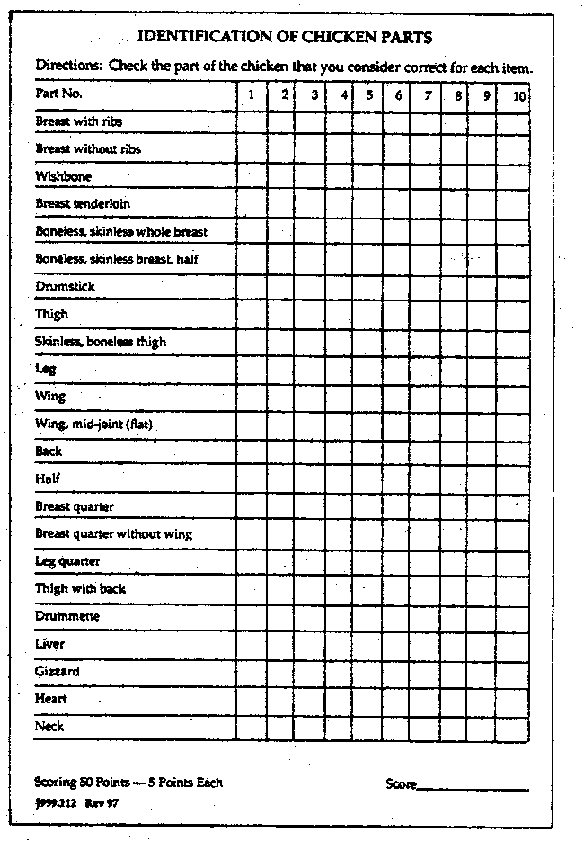
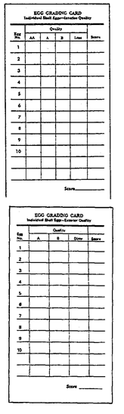
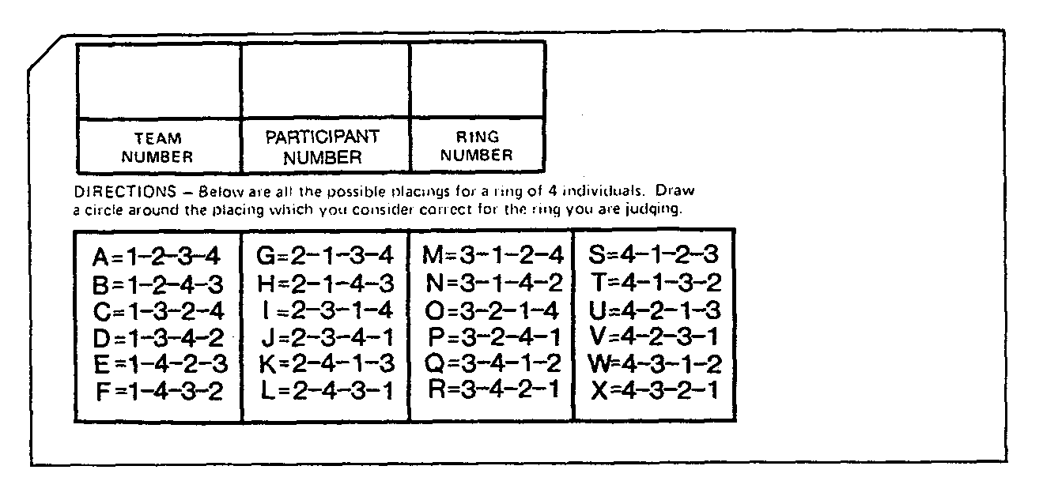
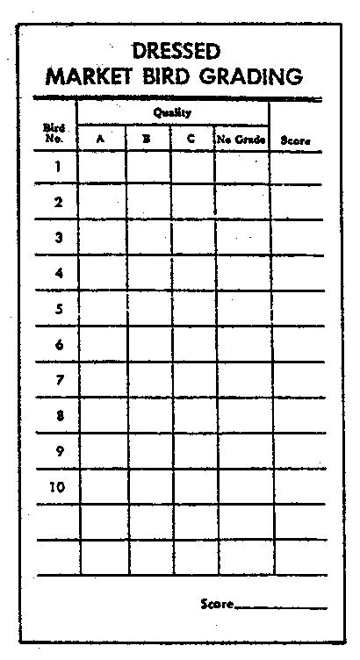
*It is important to note, this card uses only twenty three of the thirty parts that could be used at the state CDE.

