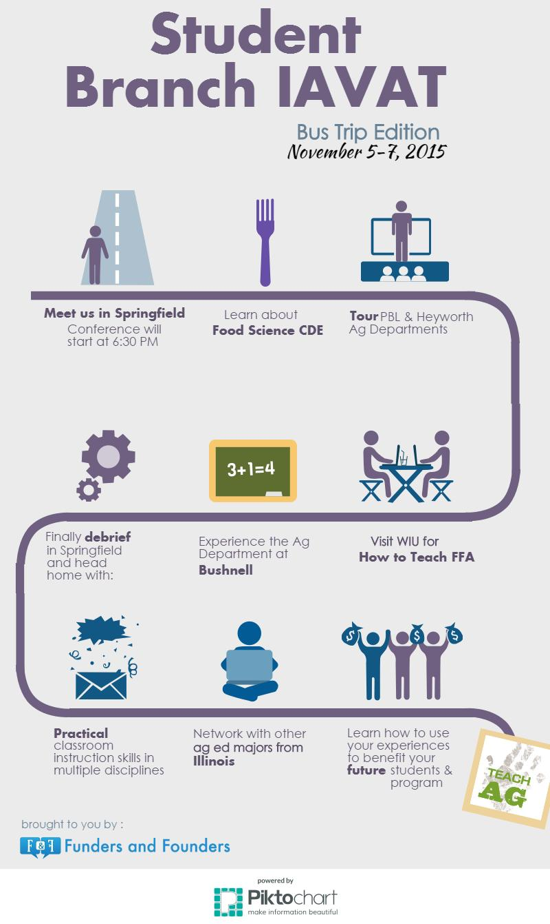

Please RSVP to Chris Clemons ([chrisclemons@siu.edu](mailto:chrisclemons@siu.edu)) by **October 26, 2015**